# **System Characterization From Data**

# Objective

You have learned in class that you can often define parameters that describe the characteristics of a system. For example in a mass-spring system, changing the spring constant *k* will impact the behavior of the system. Sometimes, you know these parameters, and you want to use them to predict how a system will behave. However, there might be other times when you can only observe the behavior of a system and you need to use your observations to find the parameters of the system. The objective of this assignment is to derive parameters of a system from data and investigate the sources of uncertainty that arise when we take this approach. We will also learn how to identify nonlinearity in a system and reflect on the implications of doing system analysis with data.

# System of Interest

The system we will be examining in this exercise is the open loop response of a small motorized cart with a voltage applied to the motor. The theoretical transfer function between the position *X*(*s*) and applied voltage *Vin*(*s*) for this system is shown in Figure 1.

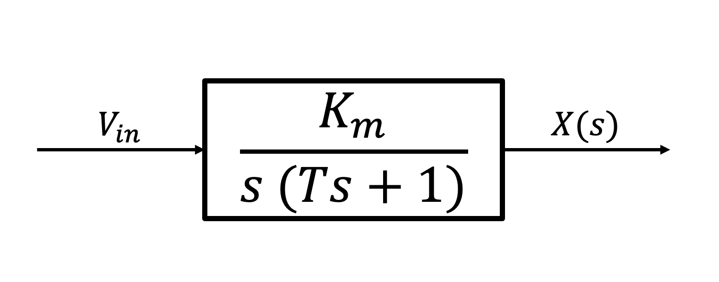

*Figure 1. Block diagram of open-loop system comprised of a motorized cart with a voltage input*

The parameter *Km* is the DC gain, and *T* is the time constant. In this exercise, we use a known voltage input and collect overhead video of the cart traveling from rest to steady-state (or near steady-state). By tracking the cart with software, you will derive position vs. time from the video, and using MATLAB, you will find a numerical derivative of position to find velocity vs. time. You will use these data to calculate the system parameters. The dataset comprises a set of videos at three different voltages for two different carts.

Next, let us look at the cart, data collection, and analysis process.

# Description of Cart

There were two carts used for this assignment. Figure 2 shows a close up photograph of one of the carts used.

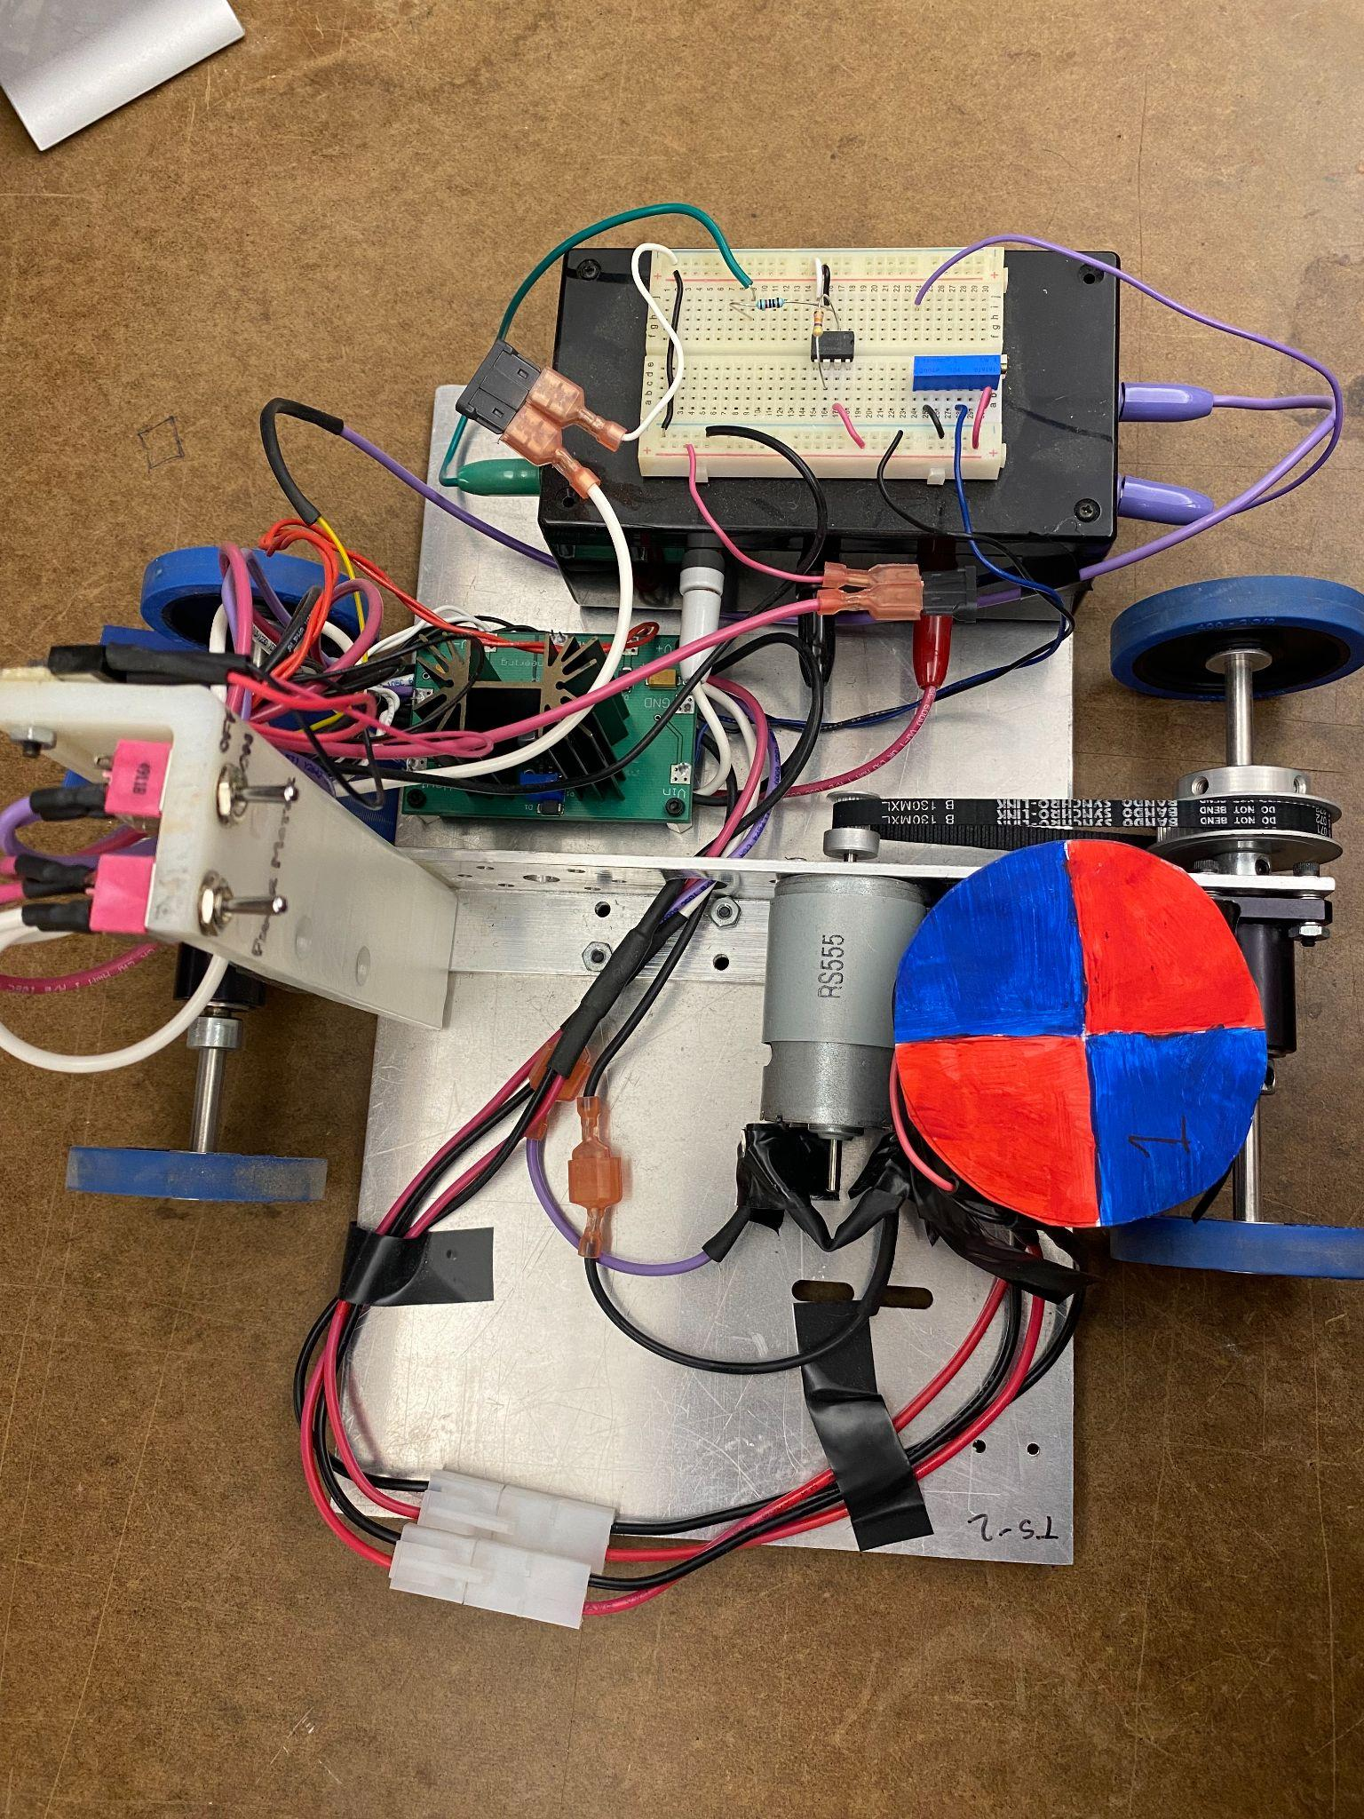

*Figure 2 Motor-driven cart*

The cart has two axles. The back wheels are belt driven and powered by a brushed DC motor, as shown on the left in Figure 3. The front wheels are not driven, i.e., the cart is rear wheel drive. The voltage to the motor is controlled by the blue potentiometer in the photo on the right of Figure 3, which can be tuned to different voltages between -12 and 12 V.

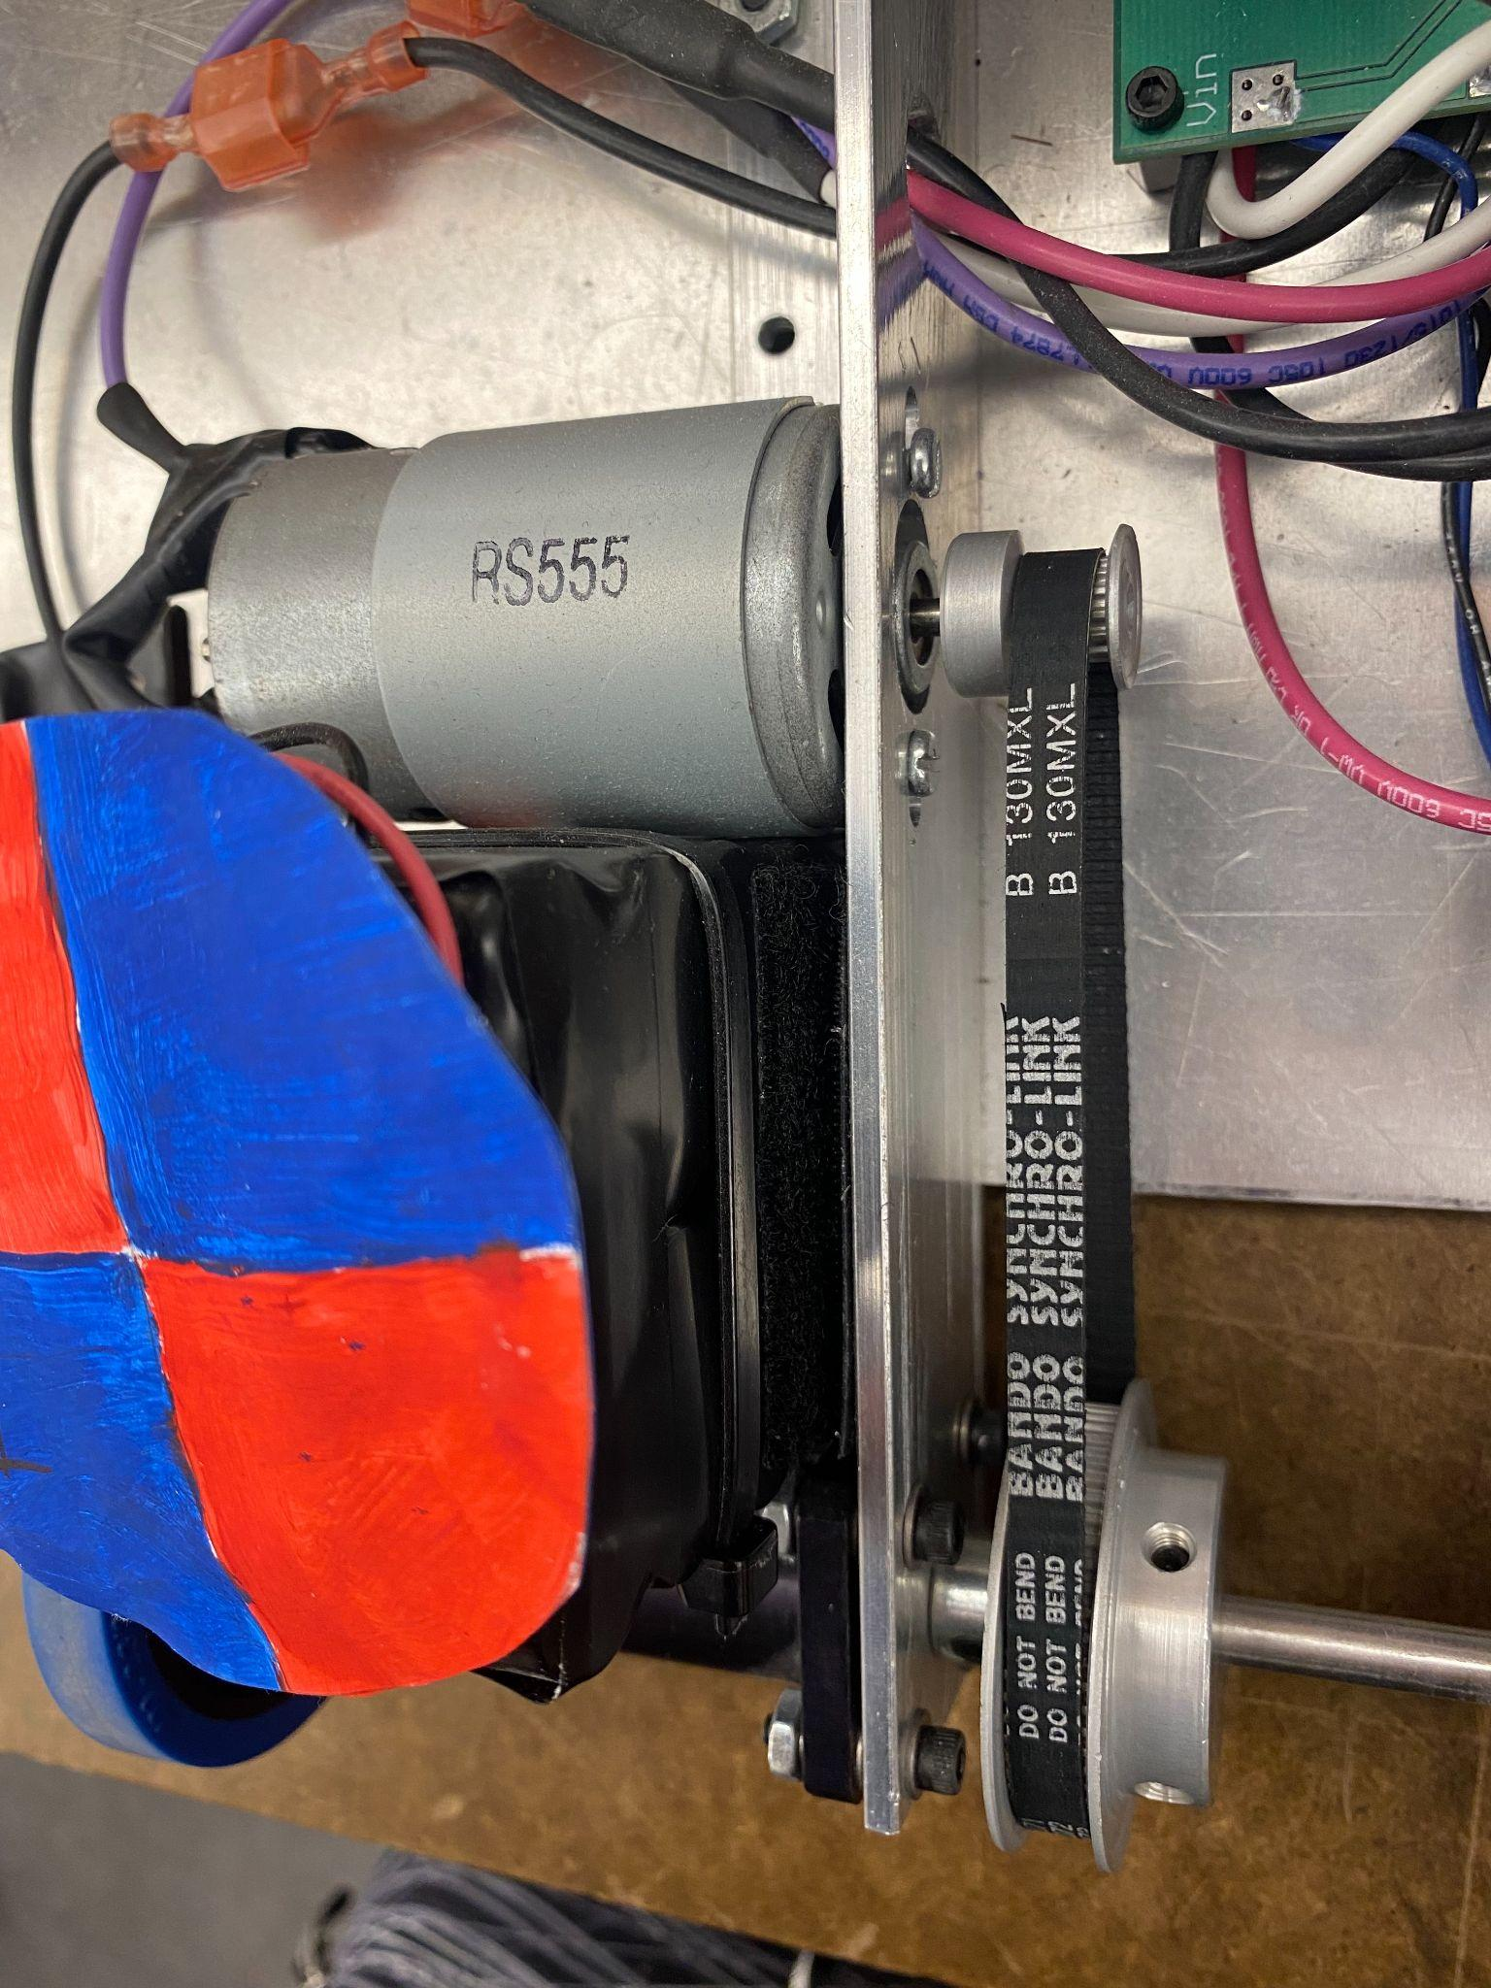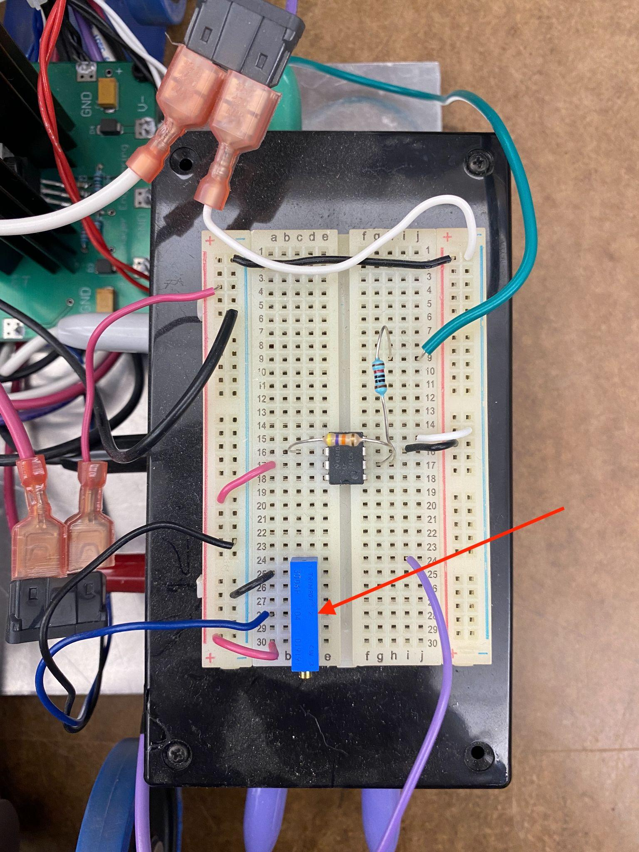

*Figure 3: (left) Belt-driven axle of the cart. (right) Potentiometer used to set the input voltage to the cart.*

# Data Collection Procedure

For the purposes of this assignment, 60 videos of the carts described above were recorded: 30 for cart 1, 30 for cart 2. For each video, the cart starts at rest. A constant voltage is applied at t=0, and the cart travels in one direction and reaches a steady-state speed. 10 videos were recorded for each cart for three different input voltages: 2.5 V, 3.5 V, and 5 V.

Each video was taken with an iPhone 11 with no zoom on the camera. The phone was held in a tripod extended over the railing of a balcony to video the floor approximately 15 feet below. The batteries of the cart were charged fully before the recording day, but the batteries were not recharged between any runs. The transit occurred over a dusty, smooth granite-tiled floor. The voltage of any particular run may be found in the spreadsheet.

You have been assigned a cart number and a run number for analysis. (find your assignment here: <https://docs.google.com/spreadsheets/d/1q7TNgZWLY8vcct2bVTScXz1pAPBghUOaYnn-BKr71Zo/edit#gid=988150530>)

Download and watch the 2.5 Volt video for the cart and run number you have been assigned.

**(Please complete the Pre-project survey to obtain the link for video download)**

Download the image Tracker software from the internet. It is free and open source: <https://physlets.org/tracker/>

Launch tracker and drag your downloaded video into the window.

The first step to using the Tracker software is to define a reference length. This is important so that the software has a length reference in physical units when calculating distance traveled. In each video, we placed a 4ft (48in) ruler stick. You can use this as a known length to scale the video frame.

To define the reference length, you will need to select the blue line in the toolbar and select “New -> Calibration Stick”

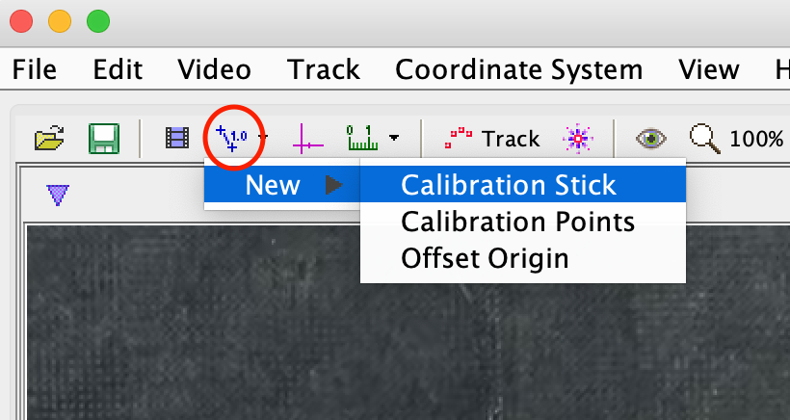

Tracker creates a calibration stick in the middle of the frame. You will need to drag each end of the calibration stick to match up with the start and end of the 4 ft measuring stick (below)

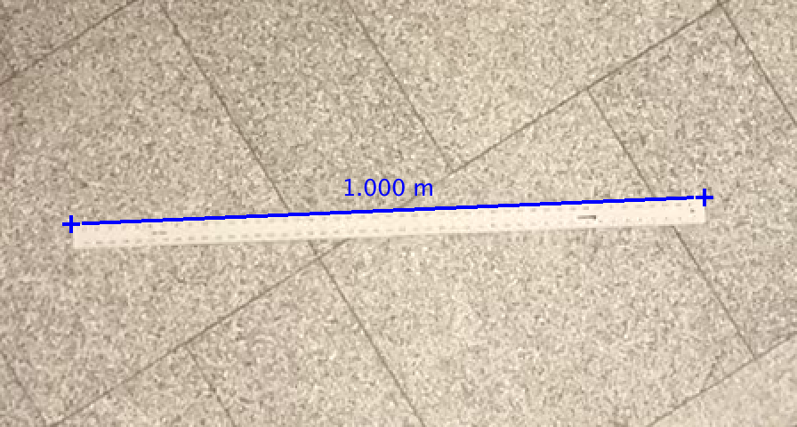

When it is created, the calibration stick has an arbitrarily-assigned length of 1 meter. To tell Tracker that the length of the ruler is actually 4ft, simply double click the blue number and type “4 ft” (including the units “ft”). Tracker will ask if you want to change units to ft. Select yes.

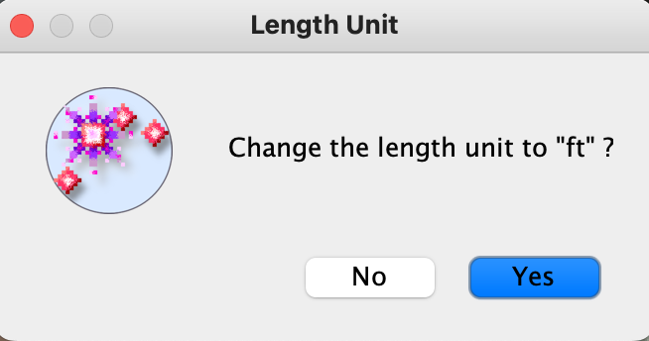

Your calibration stick should now look like this:

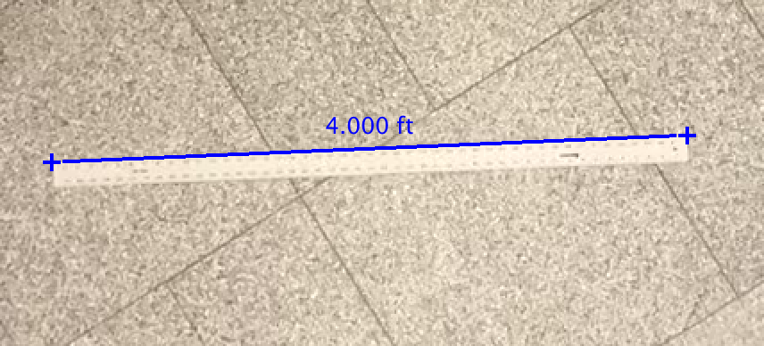

Once you have defined your calibration distance, you will need to add a coordinate system to the video. This ensures that the movement of the cart will be in only one axis. Click the pink axes button to show the axes:

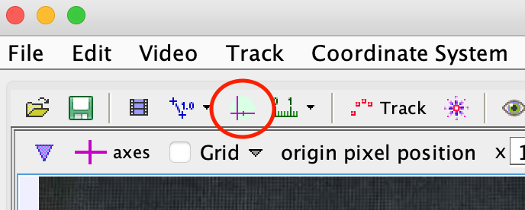

Position the origin of the axes on the blue and red target by clicking and dragging it. To get the angle of the axis correct, advance the video until the cart is farther along the screen. Rotate the horizontal axis using the toggle to the right of the origin (shown below) until the axis intersects the target on the cart along approximately its entire path. Do not simply use the blue line in the video to position your axes! The cart will approximately follow this line but may deviate slightly. After placing the axes, return (rewind) the video to the start.

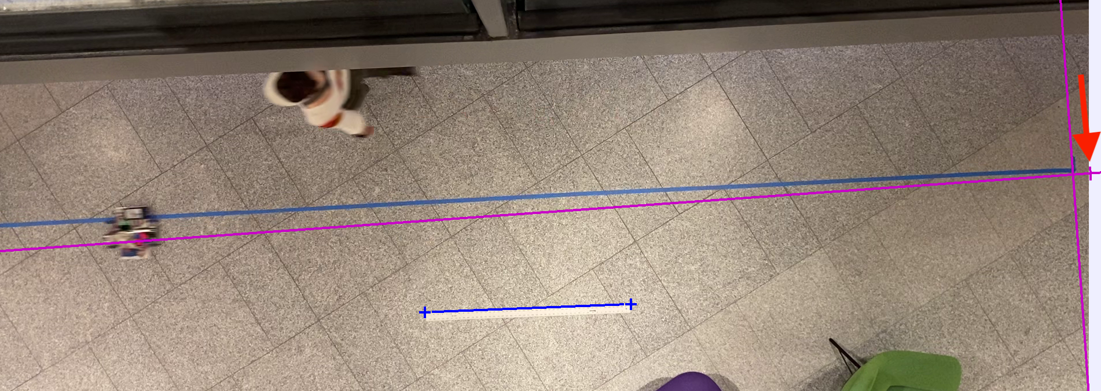

Next, you need to define the object that Physics Tracker will be following over the course of the video. To do that, first create a new point mass by going to track -> new -> point mass.

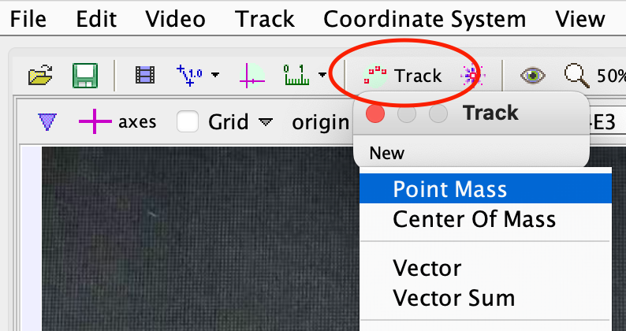

With the video bar back to the beginning of the video, use Ctrl+Shift+Click (Windows) or Cmd+Shift+Click (Mac) to select a point at the center of the blue and red target for the program to track. It is important to select as close to the center as possible. It is easier to do this if you use the zoom function to enlarge the target.

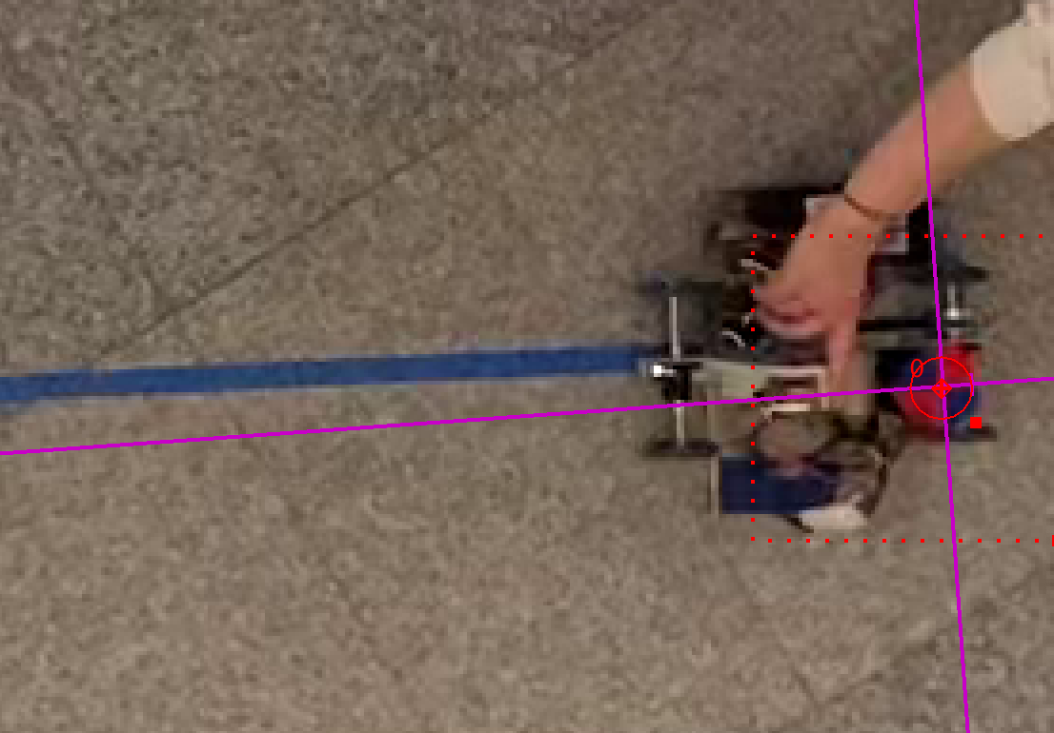

From there, a window will pop up on the right side of the program that allows you to automatically track the target over the course of travel. Click search in the top left to autotrack the target.

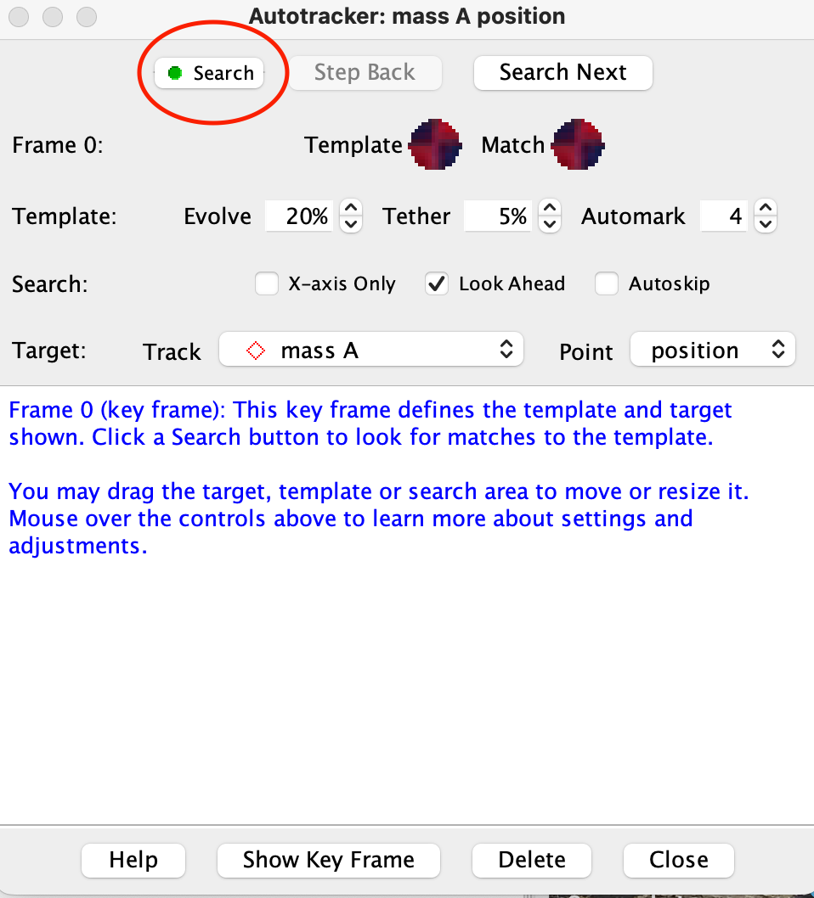

There may be moments when the tracker loses the target - to fix this, shift+click on the center of the target when the frame pauses.

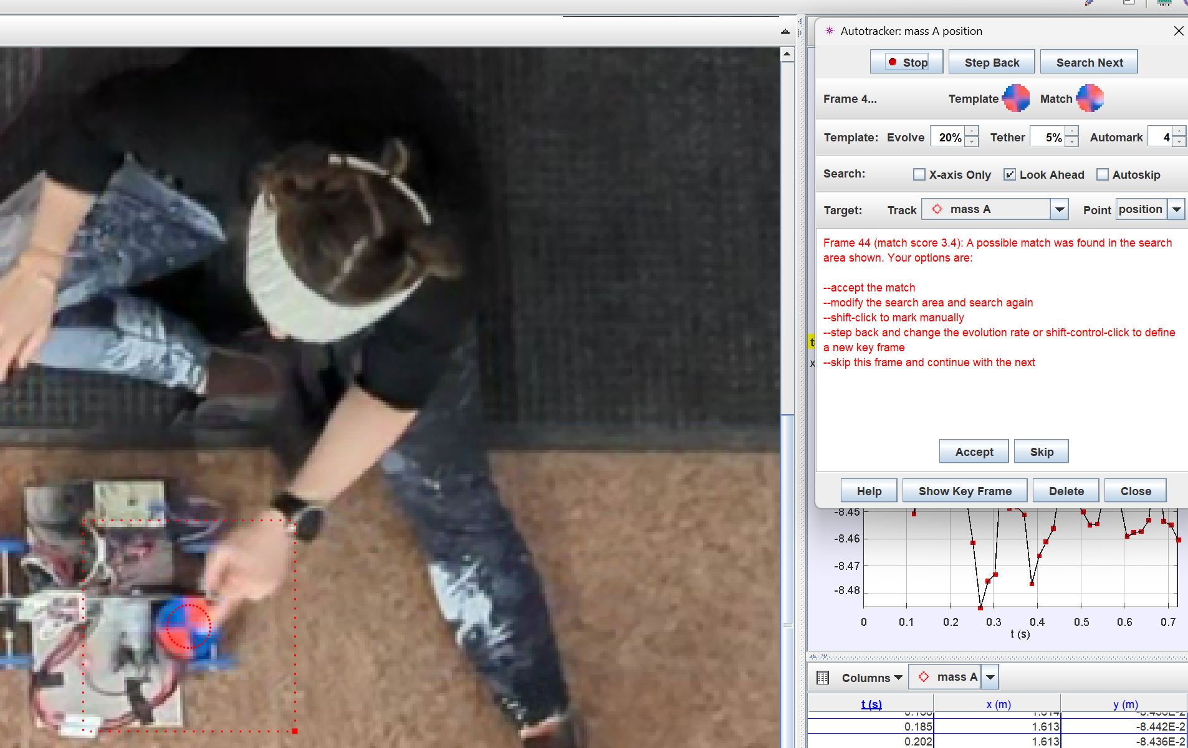

You can stop tracking once a run is complete and/or the vehicle goes out of frame. The position data of the run will be presented in the table in the lower right corner. We will use the position of the cart and the change in time to calculate velocity in Matlab.

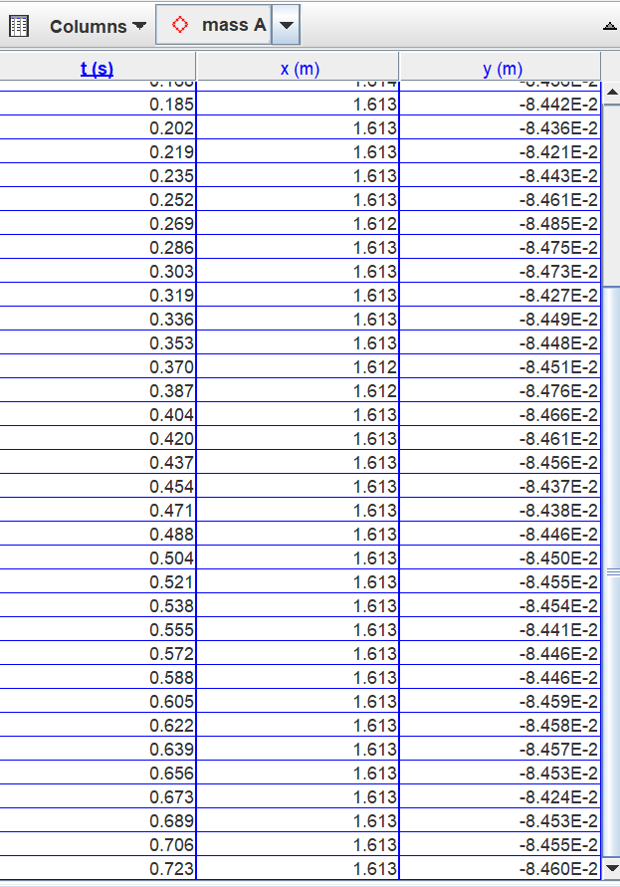

The data can be saved as a .txt file by navigating to File->Export->Data and hitting “Save As”.

# Analysis Part 1: MATLAB Processing

Once you have extracted your time series data from Tracker, you can use it to find the system parameters $K_{m}$ and $T$, as discussed in the introduction.

1. Find the transfer function system with the input being voltage to the motor and output being velocity.
2. If the motor voltage is zero for t < 0 and is constant for t ≥ 0, what type of response do you expect to get from this experiment? What type of input is this?
3. Find analytically an expression for the expected response of the system in terms of the system parameters, the input voltage, and an arbitrary initial condition.

Load your saved cart data to Matlab using the *importdata* function. This creates an array with the first column as time, the second as the x distance values, and the third as the y distance values. Find the velocity of the cart by taking a numerical derivative of the position data as follows. Create a new variable for velocity using the following MATLAB code (in this example code, the data was loaded into the variable called CartData):

dt = CartData(2,1) - CartData(1,1);

L = length(CartData);

velocity = -(CartData(2:L,2) - CartData(1:L-1,2))/dt;

To find the system parameters, it is helpful to have a plot of velocity versus time. Plot this in Matlab.

Now that you have a visual of your velocity versus time, calculate the DC gain and the time constant using methods you have learned in class. To calculate the gain, you will need to know the applied voltage, which can be found in the file name of the video.

1. Report your DC gain value and units for 2.5V as well as the method used to calculate the DC gain.
2. Report your time constant and units for 2.5V as well as the method used to calculate the time constant.

Next, repeat this procedure for the 3.5V run for your assigned cart and run number. Input your cart number, calculated DC gain, time constant, and steady state value for both voltages to the following google form: <https://forms.gle/D5UARMAAhAKWEJDY6>

1. Report your DC gain value and units for 3.5V as well as the method used to calculate the DC gain.
2. Report your time constants and units for 3.5V as well as the method used to calculate the time constant.

# Analysis Part 2: Individual Analysis

In the next part of the assignment we will answer two questions using the data we have collected: Does the data collected match the expected behavior of the system? And how much variability do we observe in the measured system parameters?

Remember that linearity for a single system can be defined in several ways. For a first-order system to be linear, you would expect the system response to follow a saturating exponential curve when subject to a step input. For this system, you have data for two different input voltages.

1. List two ways in which you can test for linearity.

Return to the data you collected for your cart and answer the following questions:

1. Does the system appear to be linear? How did you come to this conclusion?
2. Regardless of whether your system appears linear, list some possible factors that could contribute to nonlinearity in this system.

Based on the time constants and motor gains you calculated previously, simulate the response of the system to a 5V input. Additionally, repeat the video processing procedure for the 5V run and plot the velocity on the same graph.

1. Does the MATLAB plot match your collected data? Explain why you think this is or is not the case.

Proceed to Parts 3 and 4 after class data is available on the spreadsheet.

# Analysis Part 3: Class Analysis

Watch the following video of Cart 1 and Cart 2 moving next to each other. Notice that Cart 2 has a significant amount of “wobble” in its axle: <https://drive.google.com/file/d/1Z3vShnFTNd-PR44uJf7DpXcIG7LY4Pmj/view?usp=sharing>

Now look at the compiled class data for both cart 1 and cart 2 and answer the following questions:

1. Does the Steady State Velocity v Input Voltage scatter plot for cart 1 agree with your expectations of linearity?
2. Does the Steady State Velocity v Input Voltage scatter plot for cart 2 agree with your expectations of linearity?
3. Does the data seem self consistent or do there appear to be one or more outliers?
4. What other forces exist that we have not modeled in this system? How do these forces impact your answers to questions 5 and 6?

# Analysis Part 4: Reflection Questions

1. What is the mean and standard deviation of the time constant and DC gain across all of the 2.5 V runs for your cart number?
2. What is the mean and standard deviation of the time constant and DC gain across all of the 3.5 V runs for your cart number?
3. What might the effect of any outliers be on your answers to questions 16 and 17?
4. What might be the causes of variability in the time constant?
5. What might be the causes of variability in the DC gain ?
6. Refer back to the Data Collection Procedure section. How might you change the data collection and/or analysis procedure to reduce sources of uncertainty in the data?
7. Did you run into any challenges tracking the cart or otherwise collecting data? How might challenges in data collection affect your characterization of the system?
8. What other applications can you think of for these system analysis techniques? What are potential ethical issues with data collection using video?
9. Imagine you were building 1 million electric vehicles. What would the mean and variance you have computed say about performance of the product?